Python Classes

**Python Classes**

A class is considered a blueprint of objects.

We can think of the class as a sketch (prototype) of a house. It contains all the details about the floors, doors, windows, etc.

Based on these descriptions, we build the house; the house is the object.

Since many houses can be made from the same description, we can create many objects from a class.

Let's see an example,

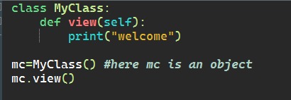

Output:

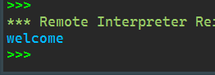

Python Object

**Python Objects**

An object is called an instance of a class.

Suppose Bike is a class then we can create objects like bike1, bike2, etc from the class.

Here's the syntax to create an object.

Let's see an example,

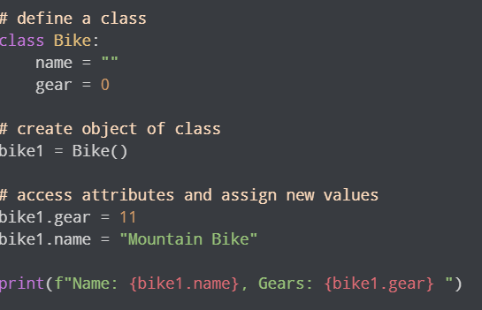

Output:

